 |  | TERMO DE ACEITE TÉCNICO
Solicitante: VIVO- Projeto Escolas Rurais
NOC/Operador: Guilherme Henrique |  |  | Cliente: VIVO
Empresa  EMC Brasil | VSAT-ID  VIVO-PER-23141123-CE |  | Link kbps  256k/128k | Plataforma  VSAT
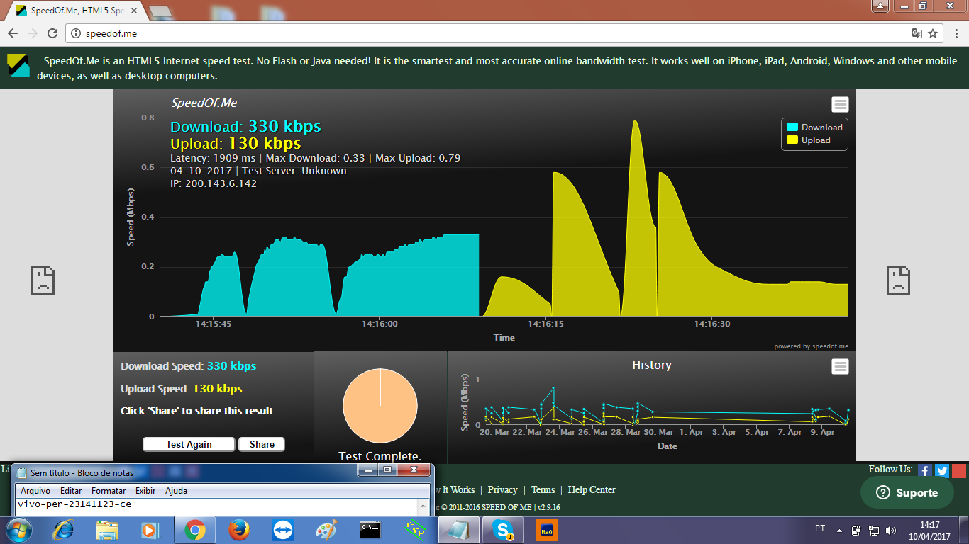

# dvb rx show

Satellite (DVB) RX Configuration
--------------------------------
Auto start : Enabled
Max Traffic MODCOD : 23 16APSK-9/10
RX watchdog : 15 minute

Idx Pri SymbRate[Msps] Freq[GHz] Mode PopId SatId Pos SatName Name Enable
* 0 0 15.000000 12.059000 DVB-S2 102 0 0.0 E Yes
1 1 9.320000 12.055825 DVB-S2 4 0 0.0 E Yes

Satellite (DVB) Receiver Status
--------------------------------
Rx State : On
DVB State : Forward link up
Network : 1326, T14R Beam
Frequency : 12.059078 GHz
Symbol Rate : 14.999873 Msps
S2 ModCod
- receiving : 19 16APSK-3/4
- current max : 21 16APSK-5/6
Pilot : On
Frame length : Short
DVB S2 Mode : ACM
DVB S2 Stream type : MPEG-TS
Roll off : 0.20
SNR : 15.3 dB
Input Power : -32 dBm
# dvb tx show

Satellite (DVB) TX Configuration
--------------------------------
Auto start : Enabled
IDU Output Power : -20 dBm
IDU Max Output Power: 0.0 dBm
Default CW Frequency: 0.000000 GHz
ATM mode : VC-Mux
Header Compression : None

Satellite (DVB) Transmitter Status
--------------------------------
State : On (DVB-RCS2)
IDU Output Power : -20.0 dBm
Es/No : 7.5 dB
Header Compression : Disabled
Timing correction : -113 us (254398 us)
Frequency correction: 30 Hz
# odu show

Antenna
---------------------
Type BrasilSat SOB107-12 - 1.2m
Antenna controller None
Tx Gain at 14.25 GHz 43.0dB

Transmitter (BUC)
-------------------------------
Type None
Local oscillator 13.050000 GHz
DC supply 24V On
10MHz Ref On

Receiver (LNB)
----------------------------
Type SatLink 403x (10.70-12.75 GHz)
Local oscillator - LO1 9.750000 GHz
Local oscillator - LO2 10.600000 GHz
Oscillator switching frequency 1-2 11.700000 GHz
LO Switching mode 22kHz
13/18V DC supply 13V

# ping 172.18.132.78
64 bytes from 172.18.132.78: time=10 ms
64 bytes from 172.18.132.78: time=10 ms
64 bytes from 172.18.132.78: time=10 ms
64 bytes from 172.18.132.78: time=10 ms
64 bytes from 172.18.132.78: time=10 ms

--- ping statistics ---
5 packets transmitted, 5 received, 0.00 percent packet loss
rtt min/avg/max = 10/10/10 ms

